MEDICAL INDUSTRIAL TRAINING
Undergone at
RAFFLES PHARMACEUTICALS, TIRUPATHI
Submitted by
PARINITHA K (170301071)
In partial fulfilment for the award for the degree of
BACHELOR OF ENGINEERING
in
BIOMEDICAL ENGINEERING



RAJALAKSHMI ENGINEERING COLLEGE
THANDALAM, CHENNAI 602 100
ANNA UNIVERSITY: CHENNAI 600 025
APRIL- 2020

BONAFIDE CERTIFICATE

It is certified that this MEDICAL INDUSTRIAL TRAINING REPORT is the work of PARINITHA K (170301071), B.E Biomedical engineering, who has undergone medical industrial training in RAFFLES PHARMACEUTICALS,TIRUPATHI, from 14thNovember2019-6thDecember2019.This report is prepared and submitted by the above student for BM17613-MEDICAL INDUSTRIAL TRAINING
University examination held on ________________.

Internal Examiner External Examiner

ABOUT THE INDUSTRY:

Raffles Pharmaceuticals was established in 2003, as a small beginning with large hope, with a vision towards empowering life and well-being. Their business focuses was on the manufacture and marketing of pharmaceutical products.
They produces wide range of quality, affordable medicines, trusted by healthcare professionals and patients across the country.
Raffles Pharmaceuticals was a loan licensee manufacturer with production at Rexer Pharma Pvt Ltd, Cherlapally, Hyderabad for the last 4 years. Now they have their own marketing team, which successfully marketed their 40 products all over Andhra Pradesh, few places in Kerala and Karnataka.
Raffles Pharmaceuticals built its own production unit built with GMP guidelines at Gajulamandyam, near Tirupati, the sacred abode of Lord Sri Venkateshwara. Built on 1.5 acres of Industrial estate land, the Production Unit supports its ORAL LIQUID SECTION, TABLET AND CAPSULE SECTIONS in its three stored building.
Raffles Pharmaceuticals is located very near to Tirupati City, compared to all other industrial areas it is well connected with transport and other infrastructure facilities. With an aim towards achieving quality medicines at affordable prices, Raffles Pharmaceuticals envisions to becoming a major national player to address the needs of India's growing population.

ACKNOWLEDGEMENT
I express my gratitude to all who have helped me in the training work. I would like to place my sincere thanks to our chairman Mr. S. Meganathan and our chairperson Dr. Mrs. Thangam Meganathan. I wish to express our intense sense of idolization and affluence to our Principal Dr. S. N. Murugesan.
I would like to express my immense sense of gratitude to our head of the department Dr. S. Rajkumar, and our Medical industrial training coordinators Mr.Jobin Christ, Associate Professor and Ms. S. Sudha, Associate Professor.
I would like to extend my sense of gratitude to our faculty advisors and Mr. Vijay Baskar Reddy, Managing Director of RAFFLES PHARMACEUTICALS,TIRUPATHI,who gave me valuable suggestions during training period. It is my pleasure to extend my gratefulness to all our faculty members, without whom this Medical Industrial training would have been a distant reality

TABLE OF CONTENT

CHAPTER TITLE PAGE

ACKNOWLEDGEMENT 4
ABOUT THE INDUSTRY 3
OUTCOME OF THE TRAINING 45
INTERNSHIP CERTIFICATE 46
1 INTRODUCTION 9

2 DEPARTMENTS IN PHARMACEUTICAL 10
COMPANY

2.1 RESEARCH AND DEVELOPMENT
2.2 CLINICAL RESEARCH
2.3 OPERATIONS
2.4 QUALITY
2.5 FINANCE AND ADMINISTRATION
2.6 BUSINESS DEVELOPMENT
2.7 PROJECT MANAGMENT
3 PARMACEUTICAL MANUFACTURING 12
3.1 TABLET MANUFACTURING 12
3.1.1 MILLING
3.1.2 GRANULATION
3.1.3 COATING
3.1.4 TABLET PRESS
3.2 PRODUCTION OF COUGH MIXTURES AND 27 PHARMACEUTICAL SYPRUPS
3.2.1 THE PROCESS
3.2.2 THE PROBLEMS
3.2.3 THE SOLUTIONS
3.2.4 SYRUP PACKAGING
4 QUALITY CONTROL LABORATORIES 37
4.1 PHARMACEUTICAL TESTING INSTRUMENT 37
4.1.1 DISSOLUTION TEST APPARATUS
4.1.2 DISINTEGRATION TESTER
4.1.3 BULK TAPPED DENSITY TESTER
4.1.4 TABLET HARDNESS TESTER
4.1.5 FRIABILITY TESTER
4.1.6 FLUROMETER
4.1.7 FLAME PHOTOMETER
4.1.8 KARL MOISTURE TITRATOR
4.1.9 LEAK TEST APPARATUS
4.1.10 MELTING TEST APPARATUS
4.1.11 PRYROGEN TELE THERMOMETER

PICTURE NO. LIST OF FIGURES PAGE NO.

- CONICAL MILL 14

- PHARMA FROM ALEXANDERWERK 16

- WP 120 PHARMA FROM ALEXANDERWERK 18

- COATING MACHINE 22

- TABLET PRESS EQUIPMMENT 25

- STAGE 1 MIXING OF SYRUP 29

- STAGE 2 MIXING OF SYRUP 30

- STAGE 3 MIXING OF SYRUP 31

- SILVER FLASHMIX 32

- SYRUP PACKAGE MACHINE 36

- DISSOLUTION TEST APPARATUS 38

- DISINTEGRATION TESTER 39

- BULK TAPPED DENSITY TESTER 40

- TABLET HARDNESS TESTER 40

- FRIABILITY TESTER 41

- FLUROMETER 41

- FLAME PHOTOMETER 42

- KARL FISCHER MOISTURE TITRATOR 42

- LEAK TEST APPARATUS 43

- MELTING POINT APPARATUS 43

- PRYROGEN TELE THERMOMETER 44
1.INTRODUCTION
A pharmaceutical company, or drug company, is a commercial business licensed to research, develop, market and/or distribute drugs, most commonly in the context of healthcare. They can deal in generic and/or brand medications. They are subject to a variety of laws and regulations regarding the patenting, testing and marketing of drugs, particularly prescription drugs. From its beginnings at the start of the 19th Century, the pharmaceutical industry is now one of the most profitable and influential in existence, attracting praise and controversy. Drug discovery is the process by which drugs are discovered and/or designed. In the past most drugs have been discovered either by identifying the active ingredient from traditional remedies or by serendipitous discovery. A newer approach has been to understand how disease and infection are controlled at the molecular and physiology level and to target specific entities based on this knowledge. New technologies and Data Management/Informatics systems are now employed to speed up this process. Drug development is considered a costly and intensive process. Of all compounds investigated for use in humans only a small fraction is eventually approved, and only after heavy investment in pre-clinical development, clinical trials, and safety monitoring to determine the safety and efficacy of a compound.

2.Following are the different departments in a Pharmaceutical company:
2.1Research and Development:
The Research and Development department determines and identifies drug candidates. In R&D department, there are three functional areas. They are discovery research, animal sciences and bioinformatics. In discovery research, experiments are performed to determine targets on the cell as well as drug candidates.

While in animal sciences department, tasks involved are providing cell cultures, growing microorganisms and taking care of animals used for discovery research. Bioinformatics is responsible for analyzing the data gathered from discovery research.
2.2Clinical Research:
Once a potential drug candidate is determined, the clinical research department comes into picture. Clinical research is responsible for approving a drug from the Food and Drug Administration (FDA). It also determines the safety and effectiveness of the drug. The regulatory affairs function is responsible for ensuring all the requirements for FDA reporting are completed and submitted on time.

2.3Operations:

The Operations department produces a salable amount of a drug. Once a drug has passed the clinical trials, the manufacturing and production department manufacture the final product, along with the packaging and labeling. Also housed under the operations umbrella is the environmental health and safety function, which assesses the environmental impact of a potential product.

2.4Quality:
There are various rules and safety regulations laid down by the FDA for pharmaceuticals and biotech firms. If found guilty for drug contamination then the FDA may close the manufacturing plant of the firm. The Quality department of the pharmaceutical firm also ensures that the firm is adhering to government regulations. There are different groups which concentrate on functions like assurance, quality control as well as validation. These groups ensure that the drugs manufactured are accurate, and of a reliable standard of quality.
2.5Finance and Administration:
The Finance and Administration department comprises different functional areas including finance, administration, legal and information systems. Responsibilities include managing activities related to finance management, handling legal relations with employees, investors, creditors as well as government regulators.

2.6 Business Development:
The Business development function recognises potential fresh coalition partners and also handles previous alliances. They are responsible for market research, recognising potential customers and preparing the promotion and pricing strategy.
2.7 Project Management:
Most of the pharmaceutical companies have a separate project management department. This department is responsible for coordinating the functions of all departments and also ensures smooth and efficient functioning. The Project management department also monitors particular projects.

3.PHARMACEUTICAL MANUFACTURING:

3.1TABLET MANUFACTURING
Drug manufacturing is the process of industrial
scale synthesis of pharmaceutical drugs by pharmaceutical companies The process of drug manufacturing can be broken down into a series of unit operation, such
as milling, granulation, coating, tablet pressing, and others.

- 3.1.1 MILLING
Milling is a device that breaks solid materials into smaller pieces by grinding crushning or cutting.
Such comminution is an important unit operation in many processes. There are many different types of mills and many types of materials processed in them.
Historically mills were powered by hand ,wind or water . Today they are usually powered by electricity.The grinding of solid materials occurs through mechanical forces that break up the structure by overcoming the interior . After the grinding the state of the solid is changed: the the grain size disposition and the grain shape.
Milling also refers to the process of breaking down, separating, sizing, or classifying aggregate material. For instance, rock crushing or grinding to produce uniform aggregate size for construction purposes, or separation of rock, soil or aggregate material for the purposes of structural fill or land reclamation activities. Aggregate milling processes are also used to remove or separate contamination or moisture from aggregate or soil and to produce "dry fills" prior to transport or structural filling
Pharmaceutical manufacturers require reliable equipment which will reduce the particle size of a drug powder to increase the surface area, increase bioavailability, improve dosage uniformity and improve formulation dissolution properties. By producing a consistent average particle size distribution (PSD), this provides manufacturers with a better-quality mixture for creating oral solid dosage (OSD) products
such as tablets and capsules.Pharmaceutical manufacturers require reliable equipment which will reduce the particle size of a drug powder to increase the surface area, increase bioavailability, improve dosage uniformity and improve formulation dissolution properties. By producing a consistent average particle size distribution (PSD), this provides manufacturers with a better-quality mixture for creating oral solid dosage (OSD) products such as tablets and capsules.
Company- Hanningfield Model-d103

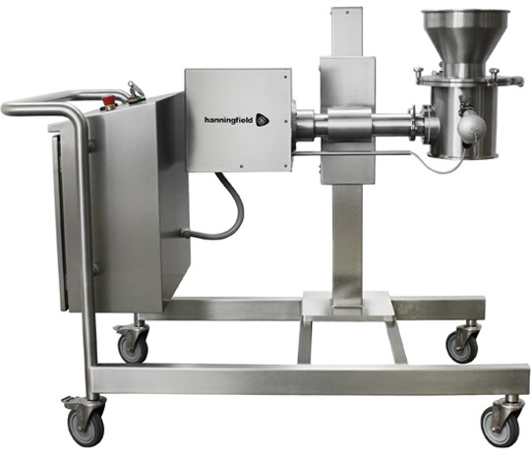

Fig 1. CONICALMILL
Courtesy-https://www.hanningfield.com/2018/03/pharma-milling-equipment/

3.1.2.GRANULATION-
Granulation is the process of forming materials into
granules. Once the granulation process is complete, granules are collected together and bonds are created through compression. Granulation is most commonly used in tablet or spheroid manufacturing. It is critical the granulation process in pharmaceutical manufacturing be predictable and repeatable in order to ensure proper levels of medication in each tablet.

In the pharmaceutical industry, two types of granulation technologies are employed: wet granulation and dry granulation.

In wet granulation, granules are formed through the addition of a granulation liquid onto a powder bed. The agitation in the system along with the wetting of the components within the formulation results in the combination of the powder particles to produce wet granules.

In dry granulation, liquid is not used in the process used because the product may be sensitive to moisture. Creating granules without liquid requires a process of compacting and densifying the powders. In this process the primary powder particles are combined under high pressure.
BT 120 Pharma from Alexanderwerk

COMPANY-ALEXANDER
MODEL- BT120 PHARMA
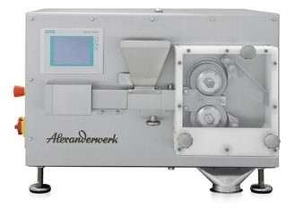
Fig 2. Pharma from Alexanderwerk
Courtesy- https://www.americanpharmaceuticalreview.com/25297-Pharmaceutical-Granulator/5822243-BT-120-Pharma/?pda=25297|5822243_1_0|||

With the BT 120 Pharma, Alexanderwerk offers a compactor for use in the pharmaceutical industry, for compacting preparations or active substances. With its highly integrated design, the extremely compact size and a throughput of up to 8 kg/ hr., it is the best machine available to advance into galenics. This machine comes with integrated electrical compacting pressure generation and control. Frequency inverters guarantee precision roller drive. All process results are fully scale-able to other roller compactors made Alexanderwerk. Derived from the latest generation of compactors and granulators, the WP 120 Pharma, this bench top model bundles the performance characteristics of its “sister model” in the smallest of spaces.

Features
  - consistent separation between the material and equipment
  - cGMP design
  - micro compacting unit for very small volumes of material
  - integrated operating unit, designed as an LCD touch panel
  - entirely made of medical grade stainless steel
  - all non-metallic materials made FDA-compliant
  - URS-compliant design
  - PLC automated
  - optional: PAT
  - optional: insulator (with separate LCD).

COMPANY-ALEXANDERWEERK

MODEL-WP 120 Pharma from Alexanderwerk

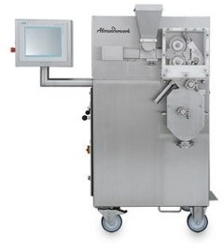

Fig 3.WP120 Pharma from Alexanderwerk
Courtesy-https://www.americanpharmaceuticalreview.com/25297-Pharmaceutical-Granulator/5821266-WP-120-Pharma/?pda=25297|5821266_2_0|||

With the WP 120 Pharma, Alexanderwerk offers a compactor and granulator specifically designed for use in R?&?D departments or small scale production. Even batches of as little as 5g can be processed on the WP 120 Pharma. The machine can equally process approx. 40kg/hr (of Lactose) making the WP 120 Pharma a good choice for frequent product changes or smaller batches, for use in a pilot plant, or in small scale production. Due to the cantilever bearing design, the rollers can be easily replaced and cleaned with little effort. The WP120Pharma is designed as a movable unit to meet the requirements of mobility and flexibility. The control and the operator panels are integrated in the machine so that the WP 120 Pharma can be quickly repositioned for use in different locations. The machine’s design meets all the requirements of the pharmaceutical industry:

Features
  - Spatial separation of process and drive equipment
  - cGMP design
  - Micro compacting unit for smallest batches
  - Two-stage rotor fine granulation in D design

- 3.1.3.COATING-

A coating is a covering that is applied to the surface of an object, usually referred to as the substrate. The purpose of applying the coating may be decorative, functional, or both. The coating itself may be an all-over coating, completely covering the substrate, or it may only cover parts of the substrate. An example of all of these types of coating is
a product label on many drinks bottles- one side has an all over functional coating and the other side has one or more decorative coatings in an appropriate pattern (the printing) to form the words and images.

A tablet coating machine is an equipment that coats the external surface of a tablet using a thin film
of coating material. ... Angled baffles are also fitted into the drum and also air flow is provided which acts as a means to mix the tablets.

Types of Tablet Coating Equipment (Main Focus Being the Working Principle)
Depending on the working principle, you may classify all the existing tablet coating machines as:
  - Standard Coating Pan
  - Perforated Coating Pan
  - Fluidized Bed Coater

As you will learn later in this article, every type of tablet coating machine tends to have a unique working principle.
Basically, this implies that the structural design will also be different.
I am sure with this knowledge, you can choose a suitable tablet coater, depending on your unique specifications.
Let’s evaluate each of these machines:

Standard Coating Pan

Standard coating pan, which is also known as the conventional pan system is a popular accessory in most pharmaceutical industries.
Basically, the design of this type of tablet coating machine is such that there is a circular metal pan whose diameter may range from 6 to 80 inches (15 to 200 cm). The pan is slightly tilted to an angle of about 45°C to the bench top.

COMPANY-HANNIGFIELD MODE-SAINTY CO

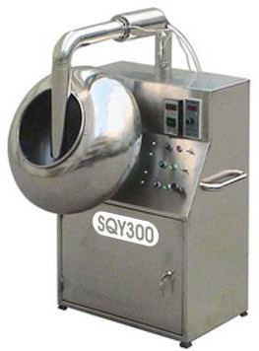
Fig 4. .SaintyCo sugar coating machine

Courtesy-https://www.indiamart.com/proddetail/peanut-sugar-coating-machine-6823042448.html

The standard coating pan has an electric motor that rotates the circular metal pan horizontally to its axis.It is the motion of this pan that causes a batch of tablets to tumble.Again the conventional pan system has an inlet air supply. This inlet port supplies heated air.
At times, very high temperature may decompose or degrade essential chemical constituents of the tablets.Remember, it is this hot air that dries the coating solution.

Again, during the process, all exhaust air will exit the system through the front section of the standard coating pan. This air leaves by means of the duct system.
This machine uses spraying or ladling mechanism to supply the coating solution.
That is, as the circular metal pan rotates, the standard coating pan system will begin to supply the coating solution.

- 3.1.4.TABLET PRESS-

A tablet press is a mechanical device that compresses powder into tablet of uniform size and weight. A tablet press can be used to manufacture tablets of a wide variety of materials, including pharmaceuticals nutraceuticals nutraceuticals, cleaning products, industrial pellets .To form a tablet, the granulated powder material must be metered into a cavity formed by two punches and a die and then the punches must be pressed together with great force to fuse the material together.

Tablet Press Machines is extremely durable and reliable. It is fabricated using supreme quality raw materials; these have numerous Features like high speed Rotary tablet press for higher table output, suitable for large batch production. is used to make different kinds and shapes of tablets which are an essential part of pharmaceutical industry. This machine can produce all types of round tablets, irregular shaped tablets and tablets engraved on both sides.
COMPANY- HANNING FIELD MODEL-D120PRO
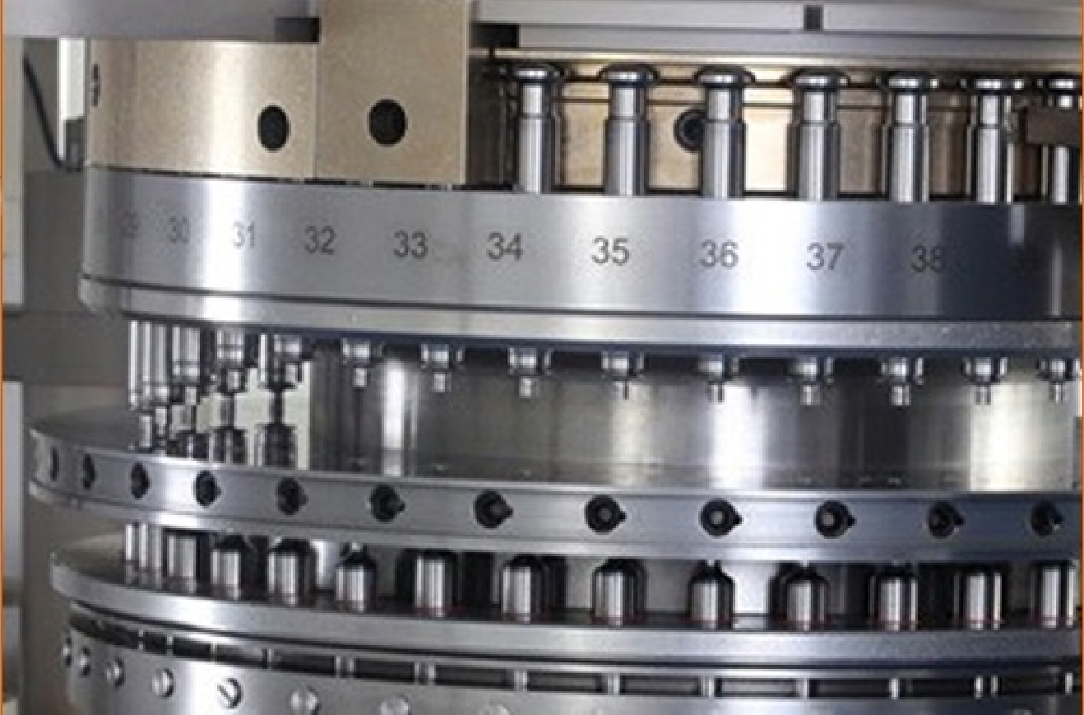
Salient Features of Tablet Press

Fig 5. Tablet press equipment

Courtesy-http://pharmamachines.in/tablet-press.html

FEATURES OF TABLET PRESS:
  - We provide a high speed Rotary tablet press for higher table output and it is suitable for large batch production.
  - Our manufactured machine is having a square design with total consideration of GMP standards.
  - All the tablet parameters can be fine tuned during the operation of the machine from outside the tableting zone.
  - The machine is having round hoppers of SS-304 with butterfly valve.
  - Lower punch seals are provided at lower punch hole in turret.
  - This machine is also having A.C. variable frequency drive for the main motor and force feeding motors, which enables operators to synchronize machine's speed & feed both.
  - Double Sided Tablet Press in compliance with cGMP Guidelines.
  - Higher Output up to 439200 tablets per hour (for 61 Station).
  - Simple and convenient operation, offering operator Protection, cleanliness and ease of maintenance.
  - AC invertor’s variable drive for main motor with electromagnetic clutch.
  - PLC / HMI System with touch screen display.
  - Auto Tablet rejection during machine START & STOP and Random sampling device.
  - This machine have powder Level monitoring device of the feed hoppers.

3.2.PRODUCTION OF COUGH MIXTURES AND PHARMACEUTICAL SYRUPS

Traditional cough mixtures are formulated around a syrup at 60 - 75% concentration which is made from sucrose, maltodextrin, glucose, invert syrup, etc. The remainder is made up of thickening agents, stabilizers and active ingredients.

3.2.1.THE PROCESS
Manufacturers of cough mixtures generally produce their own syrups as this offers greater control of product quality. The manufacturing process must achieve several functions:
- Dissolving of the sugars to form a syrup
- Hydration of powdered ingredients
- Blending ingredients of widely different viscosity
- Suspension or dissolving of active ingredients
- The end product must be smooth, agglomerate- free and homogeneous
- Equipment should conform to GMP standards

3.2.2.THE PROBLEM

Using conventional mixers and agitators for this process leads to several potential problems:
- Conventional agitators cannot dissolve high concentrations of sugars at ambient temperature.
- Heating of the mixture will be required to aid
solution. This is energy inefficient.
• The cooling process after this further adds to
costs and process time.
• Crystallization of the syrup can occur during
heating/cooling.
• Active ingredients can be damaged by heat.
• Thickening ingredients will form agglomerates
which conventional equipment cannot disperse.

3.2.3THE SOLUTION

These problems can be overcome by using a Silverson High Shear mixer. The 3 stage mixing cycle illustrated below allows the sugars and active ingredients to be dissolved at ambient temperatures.

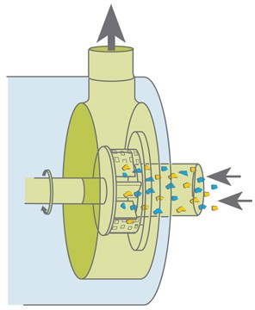
Fig 6. Stage 1 mixing of syrup
Courtesy-https://www.silverson.com/us/resource-library/application-reports/production-of-cough-mixtures-and-pharmaceutical-syrups

Stage 1
The vessel is charged with liquid and the mixer is started. The powdered ingredients are added without prior heating of the liquid. The high speed rotation of the rotor blades creates a powerful suction which draws liquid and solid ingredients into the workhead and rapidly mixes them.

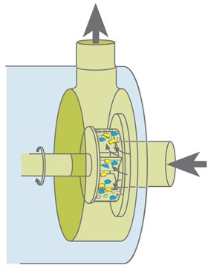
Fig 7. Stage 2 mixing of syrup
Courtesy-https://www.silverson.com/us/resource-library/application-reports/production-of-cough-mixtures-and-pharmaceutical-syrups

Stage 2
The high shear action of the mixer rapidly breaks down the sugar granules in the gap between the rotors and stator wall, exposing the largest possible surface area of sugar to the water. This greatly accelerates the solubilization process. The active ingredients are similarly reduced to a low particle size and fully dispersed into the surrounding liquid.

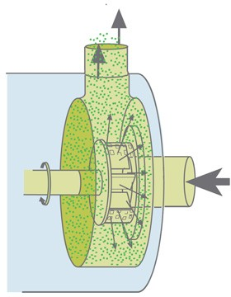
Fig 8. Stage 3 mixing of syrup
Courtesy-https://www.silverson.com/us/resource-library/application-reports/production-of-cough-mixtures-and-pharmaceutical-syrups

Stage 3
As the product is forced out through the stator, fresh powdered and liquid ingredients are drawn into the workhead and processed as before. A circulatory mixing pattern is set up within the vessel, ensuring all material is passed through the workhead many hundreds of times. This rapidly creates a very fine and stable suspension.

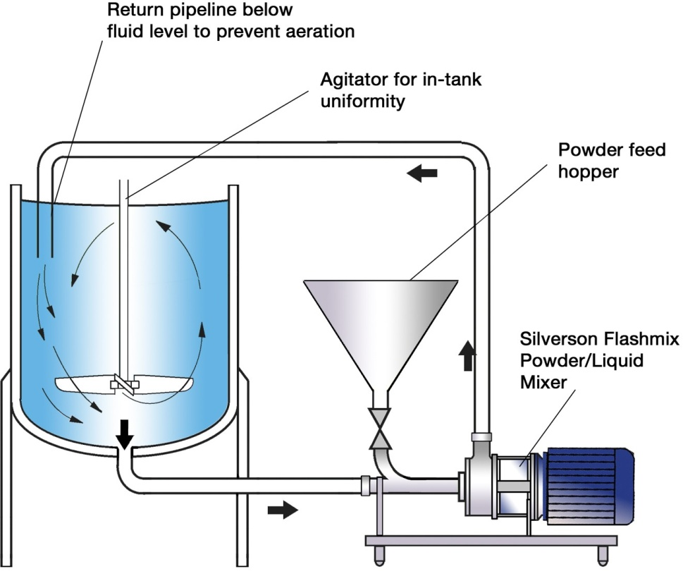
Fig 9. Silver Flashmix
Courtesy-https://www.silverson.com/us/resource-library/application-reports/production-of-cough-mixtures-and-pharmaceutical-syrups

Silverson Flashmix

˛ Kdeal for larger batches
- Capable of rapidly incorporating large volumes of
powders
- Minimized aeration
- Minimized cleaning requirements
- Suitable for higher viscosity mixes
- Suitable for operation at higher temperatures
- Minimum operator input required

3.2.4SYRUP PACKAGING

Syrup, as a pharmaceutical product requires safe, secure and tamper-proof handling while packaging. Syrup Packaging Machines needs to ensure complete protection from contamination and microbial growth. Our inevitable packaging support assures the safe and secure packaging of syrups so as to ensure their extended.

Task Performed -
As leading names in syrup packaging machines, we offer different models of packaging machines for diverse applications in the process:
- Filling
- Sealing
- Capping
- Coding & labeling
- Wrapping

The machines have unique features loaded with them so as to fulfill specific requirements of syrup packaging application.
Task Performed -
As leading names in syrup packaging machines, we offer different models of packaging machines for diverse applications in the process:
- Filling
- Sealing
- Capping
- Coding & labeling
- Wrapping

The machines have unique features loaded with them so as to fulfill specific requirements of syrup packaging application.

Process Involved in Syrup Packaging -

Empty Bottles are rinsed though Air-jet cleaning
After complete cleaning, bottles are tested & transfertp packaging machines, we offer different models of packaging machines for diverse applications in the process:
- Filling
- Sealing
- Capping
- Coding & labeling
- Wrapping

The machines have unique features loaded with them so as to fulfill specific requirements of syrup packaging application.

Process Involved in Syrup Packaging -

Empty Bottles are rinsed though Air-jet cleaning
After complete cleaning, bottles are tested & transferre cleaning
After complete cleaning, bottles are tested & transferred ahead for filling
Filling machines with their automatic piston fills the bottles with accurate volume of syrup
Capping is done on bottle though capping machines
Plastic or aluminum capsules are bound over the neck of the bottle for secure sealing
Important details regarding packaging date & expiry date are printed on bottles

COMPANY-HANNINGFIELD MODEL-AUTOMATIC404

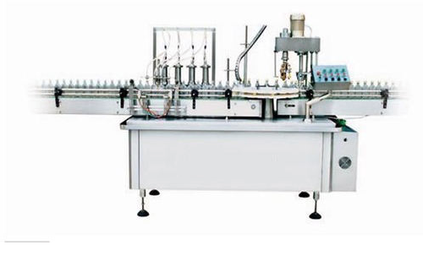

Fig 10. .Syrup package machine

Courtesy-https://www.indiamart.com/proddetail/automatic-syrup-filling-machine-13849423148.html

4.QUALITY CONTROL LABORATORIES
Pharmaceutical manufacturers continue to operate in an increasingly competitive environment, contending with issues that run the gamut from lost revenue from expired, patents, ballooning costs for new drug research and development, changes required by new regulations and other compliance mandates and global market pressures to reduce costs and improve quality and delivery.

The quality control (QC) laboratory plays a critical role in pharmaceutical production, for both in-process and ﬁnished product testing. Labs not only monitor and control the quality of incoming APIs (active pharmaceutical ingredients), and other supplies used in the manufacturing process; QC Labs are also instrumental in the batch release process.

4.1Pharmaceutical Testing Instruments
A pharmaceutical segment, develops, produces and distributes a wide array of instruments worldwide and contributes to the pharma industry at great level. From drug discovery, clinical trials, process and production, pharmaceutical testing instruments has a wide application areas.

4.1.1.DISSOLUTION TEST APPARATUS:
COMPANY-PANOMEX MODEL-PX345

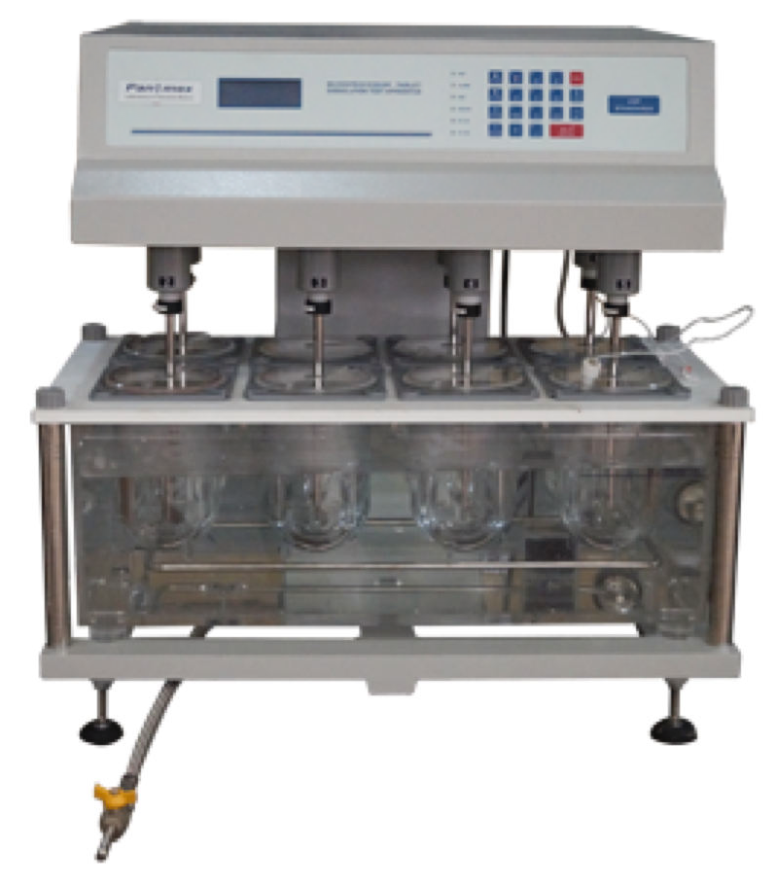

Fig 11.DISSOLUTION TEST APPARATUS:
Courtesy-http://www.panomex.com/pharmaceutical-instruments/dissolution-test-apparatus.html

Routinely used in pharmaceutical industry for drug development and quality control, dissolution testing is widely accepted method to understand the bioavailability of dosage forms (tablets and capsules) which, is important to understand the rate at which the tablet or capsule dissolves in the gastrointestinal tract, and releases the drug substance in the body. This bioavailability measurement process is precisely achieved by Dissolution Test Apparatus or Dissolution Tester.

4.1.2. DISINTEGRATION TESTER:
COMPANY-PANOMEX MODEL-PX567

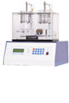

Fig 12. DISINTEGRATION TESTER
Courtesy-http://www.panomex.com/pharmaceutical-instruments/disintegration-tester.html

In pharmaceutical industry, disintegration is an essential test performed for testing disintegration capability of tablets and capsules etc as per pharmacopoeial standards like USP, BP and IP etc. Each pharmacopoeia standard has its own set of standards and speciﬁes disintegration tests of its own.
The aim of this test is to monitor quality of different dosage forms and their performance through evaluating the time a formulation (tablet or capsule) takes to completely disintegrate. If disintegration time is found too high, it is considered that the tablet is highly compressed or the capsule shell gelatin is not adhering to pharmacopoeial quality. This test is also done to check consistency and uniformity of batches; if any kind of inconsistency is found and the samples fail to provide adequate results, appropriate actions can be taken on the basis of these results.

4.1.3.BULK TAPPED DENSITY TESTER:

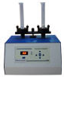
COMPANY-PANOMEX MODEL-PX458

Fig 13. BULK TAPPED DENSITY TESTER:
Courtesy-http://www.panomex.com/pharmaceutical-instruments/index.html

Designed for accurate measurement of tapped density of powders and compacts, our tapped and bulk density tester complies with USP Methods I and II and optional ASTM conﬁguration. It is a dual platform unit, which is supplied with standard sized graduated cylinder and provision to dot matrix printer.

4.1.4.TABLET HARDNESS TESTER

COMPANY-PANOMEX MODEL-PX389


Fig 14.. Tablet hardness tester
Courtesy-http://www.panomex.com/pharmaceutical-instruments/index.html

Tablet hardness testing is a kind of laboratory technique, which is employed to test breaking point of a tablet. For pharmaceutical units this process is an important part of medicine production that ensures tablets must be hard enough to withstand mechanical stress during various conditions such as storage and packaging, transportation and handling by the consumer et
4.1.5.FRIABILITY TESTER:

COMPANY-PANOMEX MODEL- PX/FTA-902

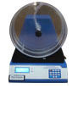

Fig 15. Friability tester
Courtesy-http://www.panomex.com/pharmaceutical-instruments/index.html

Friability testing is the widely accepted technology to determine tablet hardness as per Pharmacopeia standards. Available in one or two drum models, our friability testers offer accurate analysis and fast processing through microprocessor based circuit and user-friendly menu controls. These Friabilators also feature provision to connect digital weighing balance and dot matrix printer.

4.1.6.FLUROMETER
COMPANY-PANOMEX MODEL- PX/FTA-681

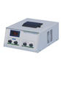

Fig 16. FLUROMETER:
Courtesy-http://www.panomex.com/pharmaceutical-instruments/index.html

We design and manufacture digital photoﬂuorometers for life science laboratories, where these systems are utilized for accurate and fast analysis of ﬂurophors and quinine. These ﬂuorometers are compact and efﬁcient and provide excellent analytical performance with features of simple operation and easy maintenance.
4.1.7.FLAME PHOTOMETER:

COMPANY-PANOMEX MODEL- PX1382
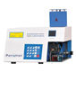

Fig 17. Flame photometer
Courtesy-http://www.panomex.com/pharmaceutical-instruments/index.html

A digital photoﬂuorometer, you can perform precise analysis
of ﬂurophors and quinine. Designed speciﬁcally for life science laboratories, this smart instrument fulﬁlls your requirements of accurate results with the sensitivity you demand. This ﬂuorometer is a compact system, which occupies very low bench space, while offering convenient and excellent throughput for ﬂuorescence assays..

4.1.8.KARL FISCHER MOISTURE TITRATOR:
COMPANY-PANOMEX MODEL- PX1760

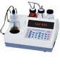
Fig 18. KARL FISCHER MOISTURE TITRATOR
Courtesy-http://www.panomex.com/pharmaceutical-instruments/index.html

We manufacture Karl Fischer Moisture Titrator for easy and simple titration measurement. It employs volumetric method to determine water content in sample.
4.1.9.LEAK TEST APPARATUS:
COMPANY-PANOMEX MODEL- PX1961

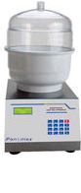

Fig 19. Leak test apparatus
Courtesy-http://www.panomex.com/pharmaceutical-instruments/index.html

Presenting leak test apparatus models enriched with enhanced features of testing packing and seal integrity of blisters, tablet strips, pouches and bottles. Provision of printer is given in GMP model.

4.1.10.MELTING POINT APPARATUS:

COMPANY-PANOMEX MODEL- PX965

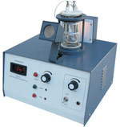

Fig 20. MELTING POINT APPARATUS
Courtesy-http://www.panomex.com/pharmaceutical-instruments/index.html

Invest smartly in melting point apparatus by Panomex Inc. We offer a range of instruments for determination of boiling points, melting points and melting ranges of various types of chemicals substances.
4.1.11.PRYROGEN TELE THERMOMETER:

COMPANY-PANOMEX MODEL- PX461

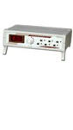

Fig 21. PRYROGEN TELE THERMOMETER
Courtesy-http://www.panomex.com/pharmaceutical-instruments/index.html

This Pyrogen Tele Thermometer offers convenient functioning; it has the ability to monitor temperature of 6 different rabbits simultaneously. The instrument is provided with a set of 6 Pyrogen probes, which are used in in-built 6 channels. The selection of channels is done through rotary switch ﬁtted on the front panel. In addition to these features and this pyrogen instrument is available at very low cost and guarantees excellent performance as compared to other Indian make models.
OUTCOME OF INTERNSHIP:

The industrial training at Raffles Pharmaceuticals, Tirupathi, was very
interesting and informative where I was able to gain a lot of experience on how work is being done in a drugs manufacturing company. Being there, I had a wide range of exposure to various medical drug manufacturing equipment, machineries and quality checking instruments. I was also able to
have an overall idea about the roles and duties of biomedical engineers in a
pharmaceutical company and their work in the maintenance of the equipment and functioning of the company. From the industry point of view I came to know my role in pharmaceutical.

THE INTERN CERTIFICATE: 